IJIAMR Guidelines for title, Capitalize first alphabet & proper nouns
Author Name¹, Author Name², Author Name^{3*}
*: Corresponding Author
¹ Author Affiliation, email, ² Author Affiliation, email, ³ Author Affiliation, email

ABSTRACT
All manuscripts must include an abstract containing no more than 250 words. This section should detail the problems, experimental approach, major findings, and conclusion in a single paragraph. The abstract should not contain any references or undefined abbreviations.
Keywords (5-6): Keyword 1, Keyword 2, Keyword 3…..Please provide 4 to 6 keywords that can be used for indexing purposes. Do not repeat words that already appear in the paper’s title.

- INTRODUCTION
This template shall help you to properly format your manuscript for IJIAMR. Your contribution may be prepared in LaTeX or Microsoft Word.
- PREPARATION OF YOUR PAPER

  - Sub-heading
  - Sub-heading
    - Sub-Sub Heading
  - Sub-heading

- FIGURES
Each figure and scheme should have a caption and should be inserted in-line within the main text. All figures and schemes must be mentioned in the text in numerical order.
All illustrations must be clear and legible. Vector graphics (rather than rasterized images) should be used for diagrams and schemas whenever possible. Please check that the lines in line drawings are not interrupted and have a constant width. Grids and details within the figures must be clearly legible and may not be written one on top of the other. Line drawings are to have a resolution of at least 800 dpi (preferably 1200 dpi). The lettering in figures should not use font sizes smaller than 6 pt (~ 2 mm character height). Figures are to be numbered and to have a caption which should always be positioned under the figures.

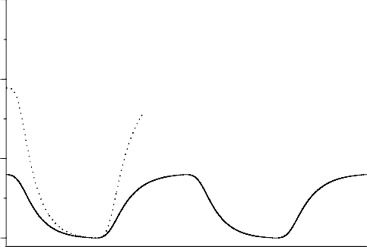
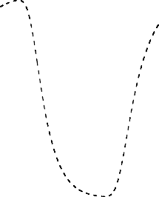
third span

second span
first span

Fig. 1. Power distribution of channel at 1555 nm along the line of 383 km

Captions are set in 9-point type. If they are short, they are centered between the margins. Longer captions, covering more than one line, are justified. Captions that do not constitute a full sentence, do not have a period.

If screenshots are necessary, please make sure that the essential content is clear to the reader.

- TABLES
Tables should be provided with a brief legend and should only be subdivided according to the template given. For footnotes in tables, Roman lowercase letters followed by a closing parenthesis should be used. All tables should be numbered (Arabic numerals) in the sequence in which they are referred to in the text. When tables are cited in the text, the word “Table” should be used without abbreviation.
Table 1. Font sizes of headings. Table captions should always be positioned above the tables.
Heading level | Example | Font size and style
Title (centered) | Lecture Notes | 14 point, bold
1st-level heading | 1 INTRODUCTION | 12 point, bold
2nd-level heading | 2.1 Printing Area | 12 point, bold
3rd-level heading | Run-in Heading | 12 point
General Text | Text follows | 10 point

- FORMULA AND EQUATIONS
Equations or formulas are centered and set on a separate line (with an extra line or half line space above and below). Equations should be numbered for reference. The numbers should be consecutive within the contribution, with numbers enclosed in parentheses and set on the right margin.
x + y = z (1)

ACKNOWLEDGEMENTS
An (unnumbered) acknowledgements section may be inserted if required.
CONFLICT OF INTEREST STATEMENT
All authors must declare financial/commercial conflicts of interest. If the authors have no conflicts of interest, this should be stated.
ETHICAL DECLARATIONS
The authors declare that this research does not involve human participants, animals, or any procedures requiring ethical approval. All data used in this study were obtained and processed in accordance with applicable ethical and legal guidelines.
REFERENCES
All references must be arranged first alphabetically, and then they may be further sorted chronologically. If the reference is provided from the same Author (s) in the same year, it must be identified by the letter "a", "b", "c", etc which is placed after the publication year. Ex. (2000,"a") References should be the last part of the article following the below given format.
Prakash. R., & Ramesh G.R., (2008). Article title, Journal of American Society of Civil Engineers, 23(2),12-15.
Prajesh G., (2004). Article title, Journal of Applied Engineering, 45(2),13-17.
Books:
P. K.Gupta., (2006). Introduction to Operations Research, 3rd. Ed. McGraw Hill Inc, 34-96.
Book chapter:
Botkin,J., (2006). What do you meant by Ecosystem in: Environmental Science of Living Plater, 3rd edition, E-age Publishing, New York.
Conferences:
Ganeshkumar. B, " Geospatial technology for disaster management", International Conference on Disaster Mitigation and Management, PSNA College of Engineering and Technology, Dindigul, pp 234-238.
Note: Reference should be in APA Format (http://www.apastyle.org/faqs.html#8 or http://www.apastyle.org ).

